Yiting (Tina) Li
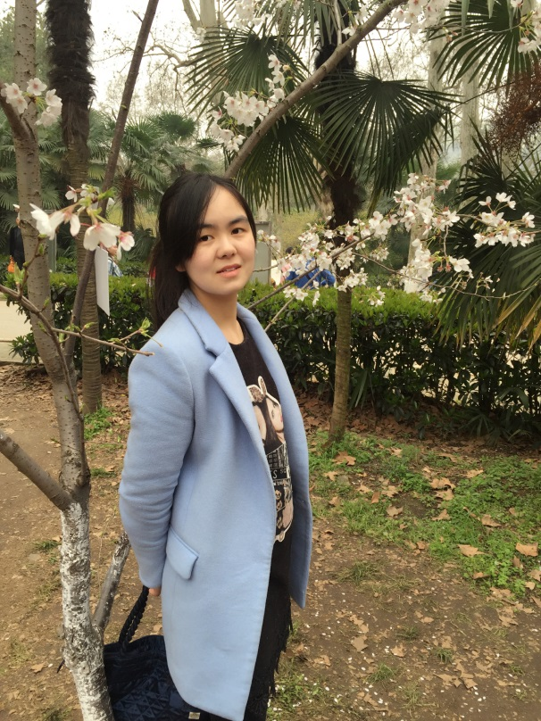
My name is Yiting Li, I am also known as Tina. I am twenty four years old. I come from Nan Yang, a beautiful city in the Henan province, Central China. I am easy-going and like to make friends with other people. I can play the guzheng, a traditional Chinese instrument. I also enjoy paper cutting, Tai Chi, cooking and making Chinese knots. I will be working as a Language Teaching Assistant at Bonnyrigg High School until December. Currently, I am doing a master’s degree at Soochow University, majoring in Teaching Chinese as a second Language.
I love my study so much that I never regret spending time and energy on it. I am hard working and often receive scholarships from my university. In my spare time, I enjoy participating in many different activities. When I was a sophomore I was a volunteer at Chinese Bridge Summer Camp in Henan province, teaching American students for two weeks in June 2011. I also participated in a talent show, playing guzheng, at East China Normal University in November 2014. I was an assistant teacher and language partner in the Critical Language Society at Soochow University from June to August 2015. Finally, I was teaching Chinese speaking classes at Soochow University from September to November 2015. In the future I want to be a Chinese teacher and I am determined to devote myself to my teaching career.
我是李怡婷，英文名字叫Tina，今年24岁。我的家乡在中国中部的河南省南阳市，是一个非常美丽的城市。我非常随和，很喜欢与别人交朋友。我会弹古筝、编中国结、剪纸、打太极、做中国菜等等。我在邦尼里格公立中学当汉语助教到今年12月份。如今，我是苏州大学汉语国际教育的在读研究生。
我很热爱我的专业，并不遗余力为我的专业付出努力。我努力学习，常常获得学校的奖学金。在我的业余时间，我很乐意参加各种活动。比如，2011年6月，我是大二的学生时，我参加了河南省汉语桥夏令营做一名汉语志愿者教美国学生学习汉语2周。2014年11月，我参加了华东师范大学举办的才艺大赛。2015年6月到8月，我参加了苏州大学的关键语言项目做为一名助教和语伴。2015年8月到11月，我在苏州大学教汉语口语课。以后我想当一名汉语老师，致力投身于汉语教师事业。 