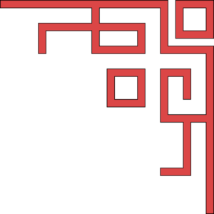
Confucius Classroom Opening

The opening of Confucius Classroom was held on 5th December 2016.
We were honoured to have so many guests join us in celebrating the official opening.
It was very kind of them to brave the heat and come out to visit us for this special
occassion.

A beautiful souvenir booklet was created by Ms Hong, showing each stage of the ceremony and who would be performing each stage. We are very proud to have been able to provide both English and Mandarin for our guests to be able to enjoy the presentations. To see a copy of the booklet in English please click on the link below.

After enjoying the specially prepared performances our dignitaries moved on to the official opening of the Confucius Classroom. Thank you to all staff who helped to prepare our Confucius Classroom, it was stunning.
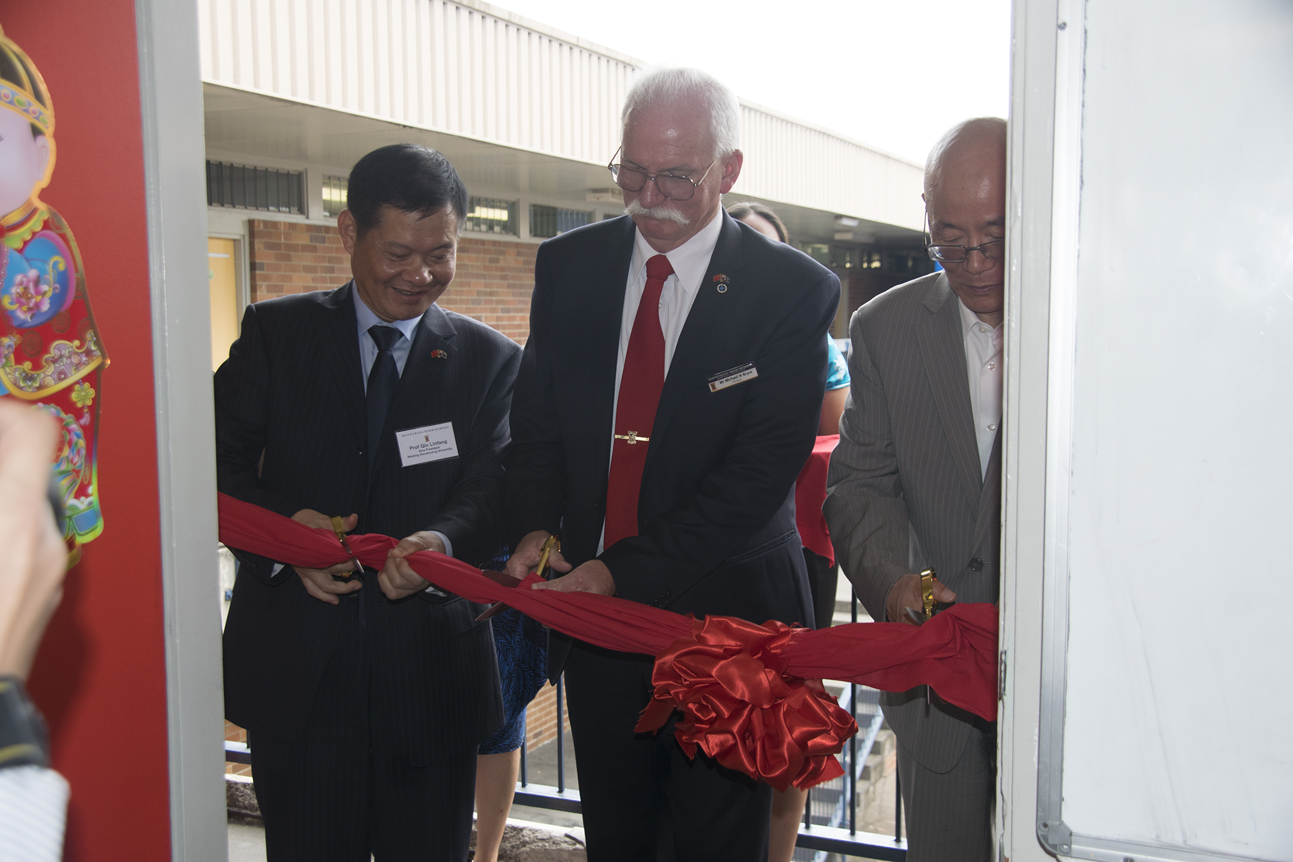

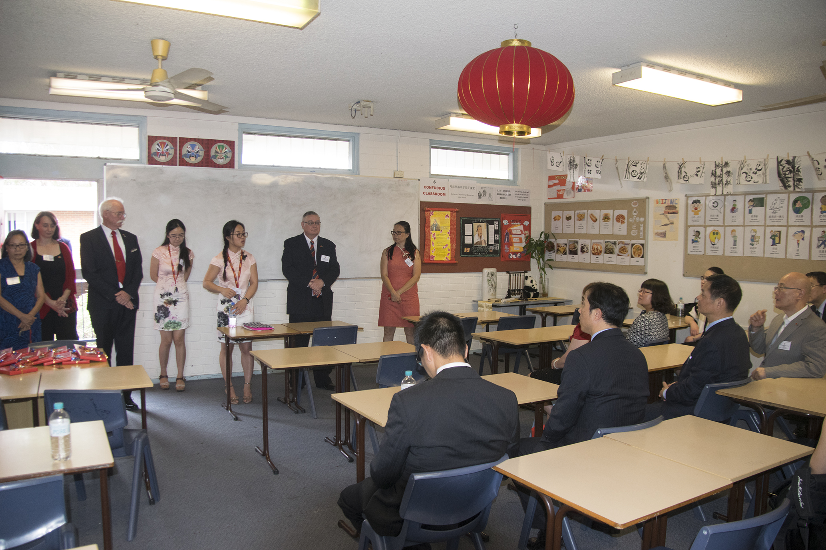Our New Classroom

Lunch with our Distinguished Guests
Performers
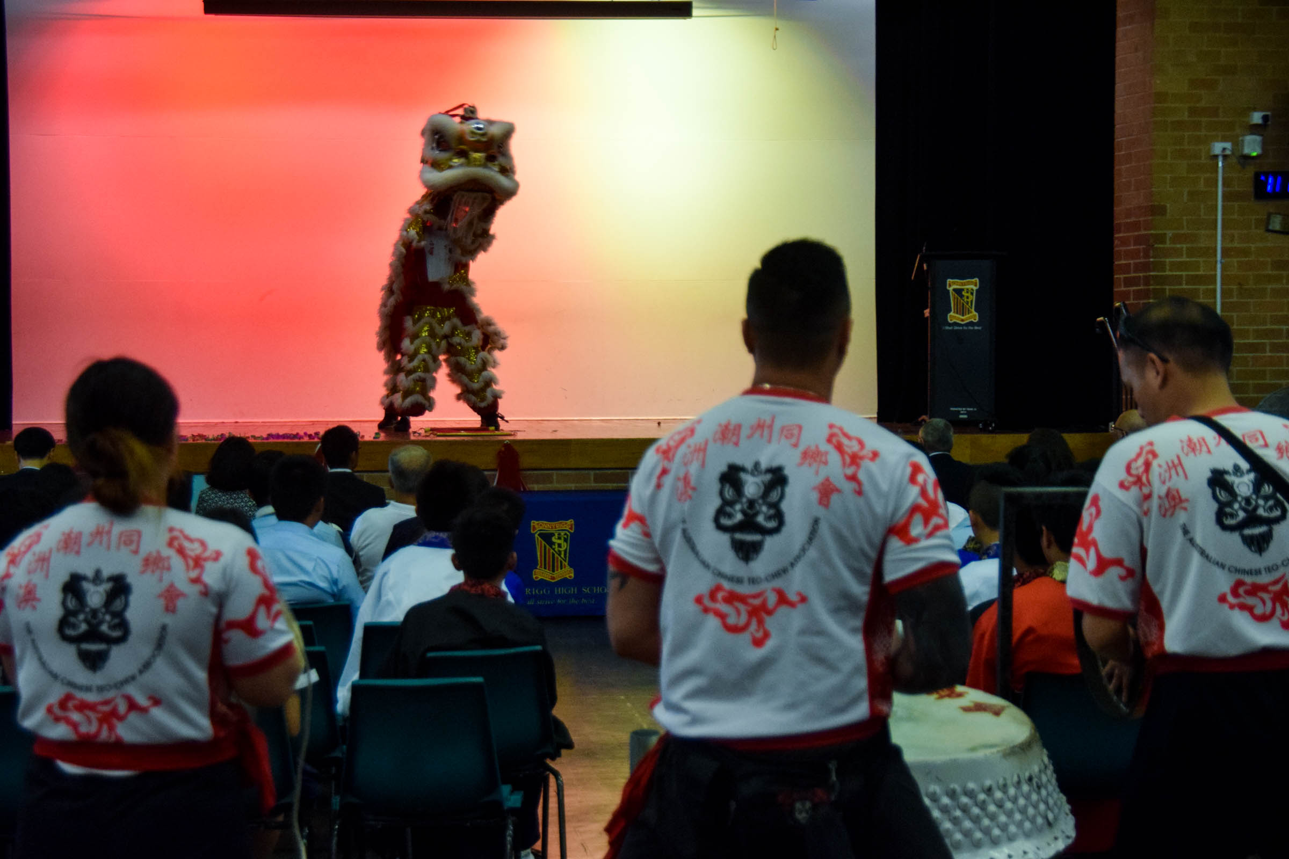Thank you to Australian Chinese Teo-Chew Association Lion Dance Team

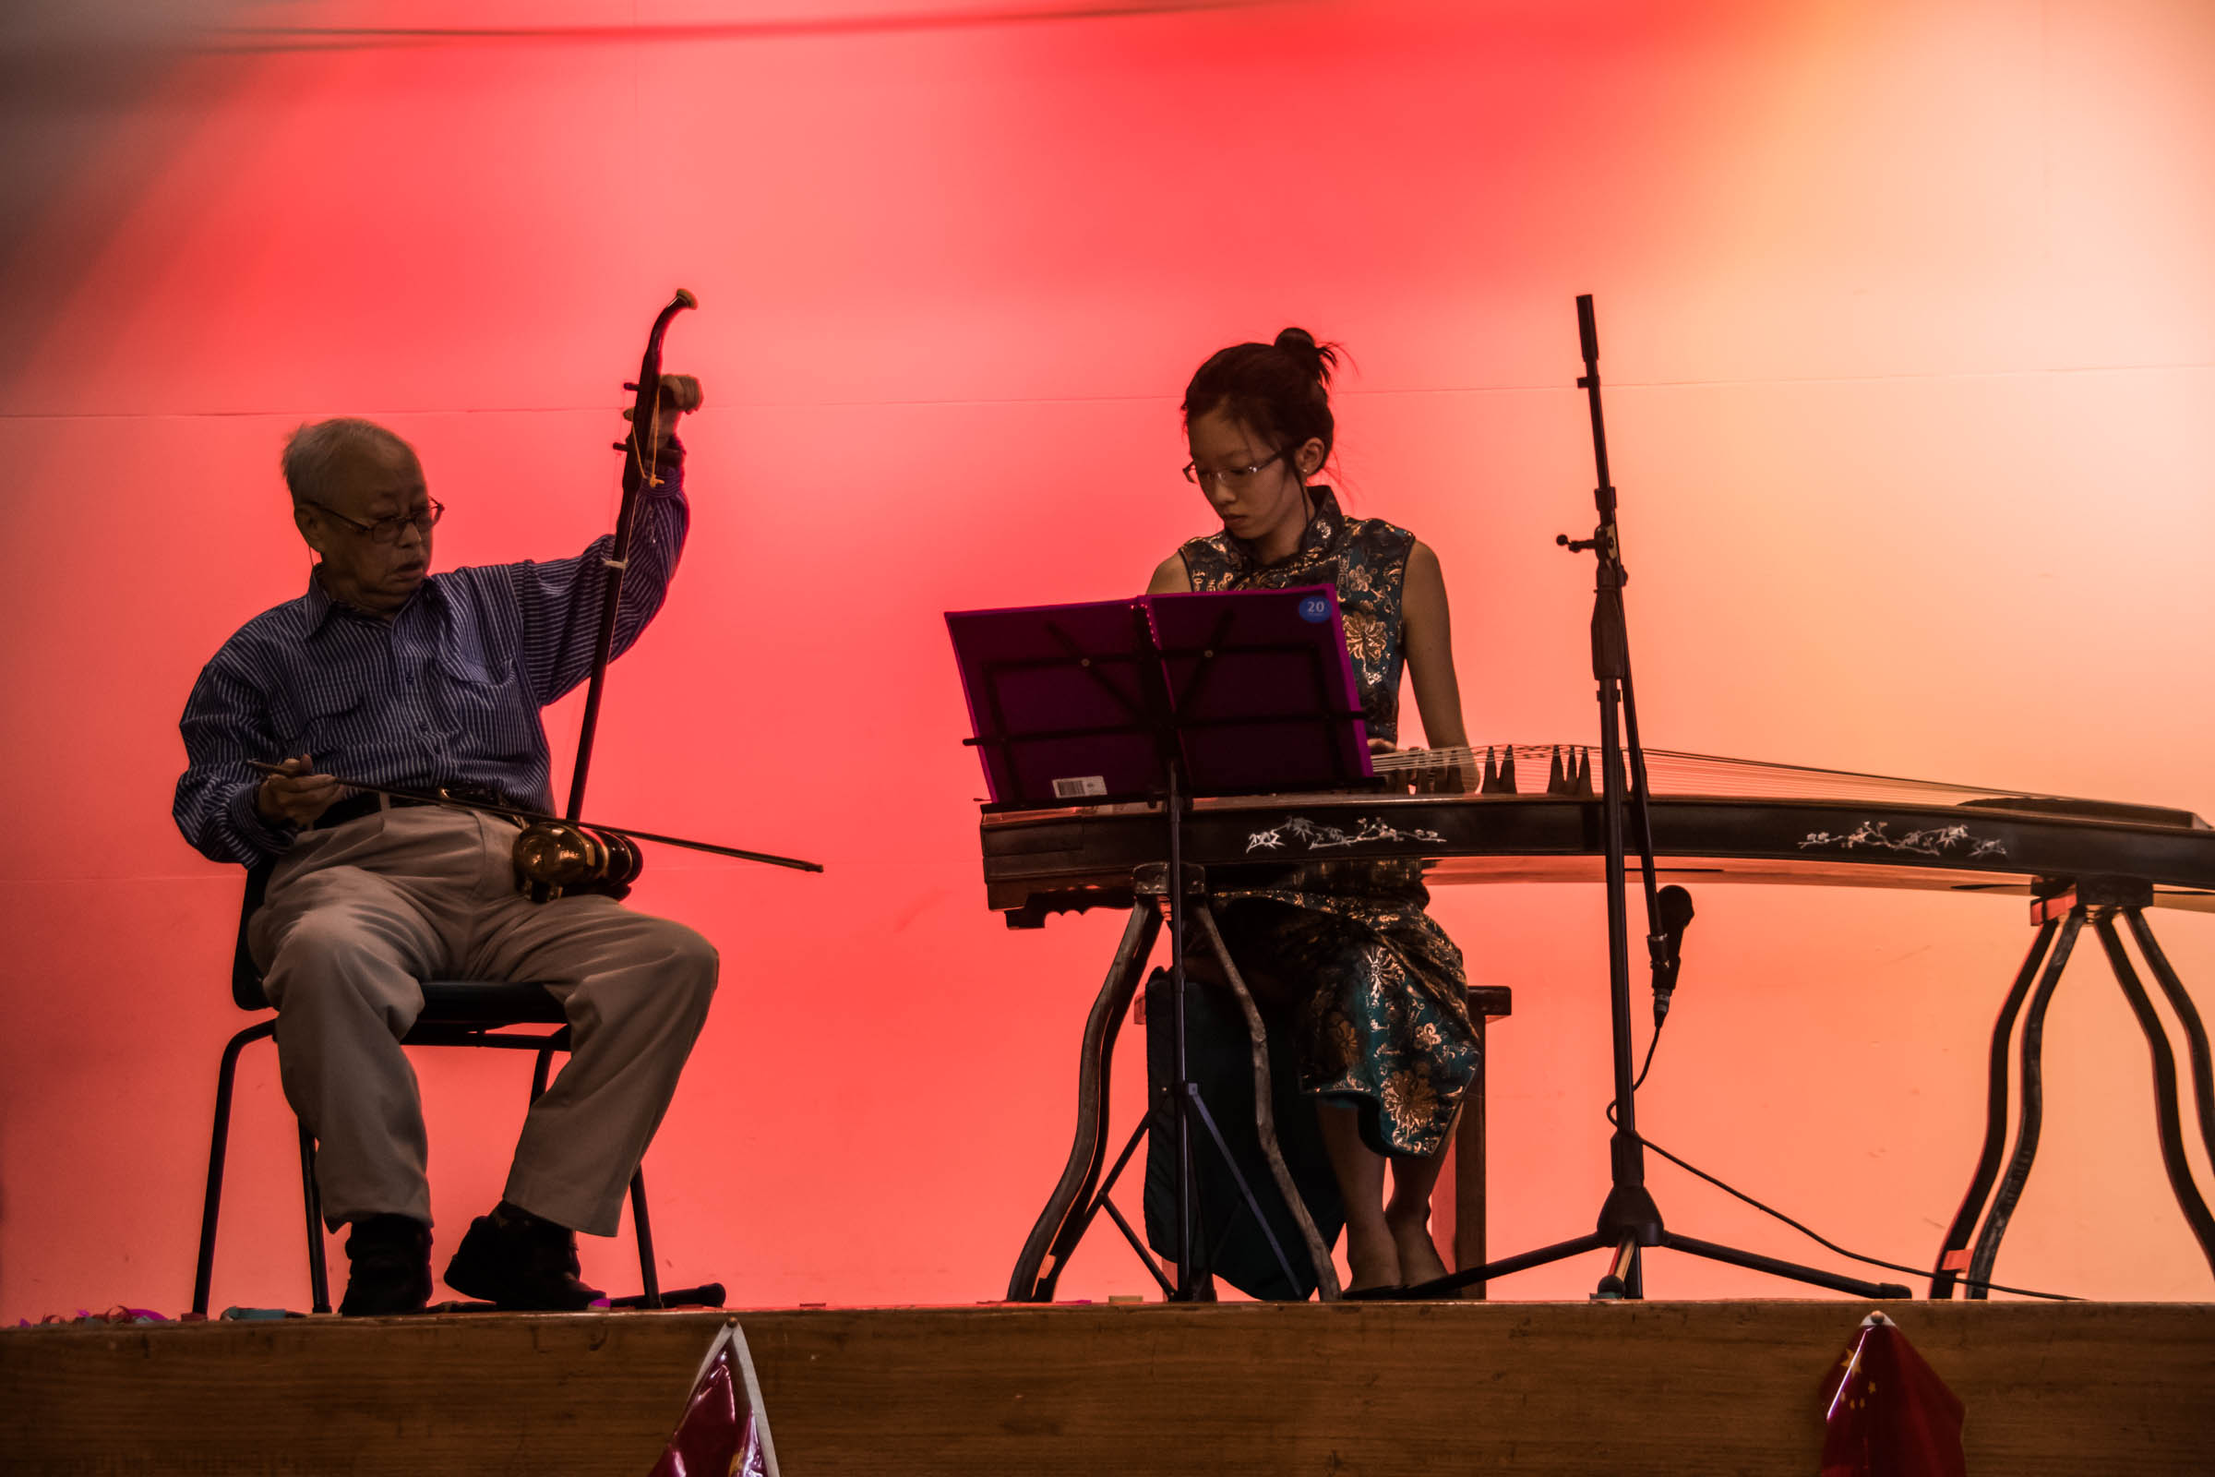Guzheng Performance – “Spring River Flower Moon Night”

