My name is Junxia Hao, and my English name is Jasmine. I come from China. My hometown is Handan, a city in the Hebei province with more than 2,500 years history. Many Chinese historical quotes and idioms come from this region. I am doing my Master degree at Capital Normal University in Beijing, majoring in Teaching Chinese as a Second Language. I will be working as a Language Teaching assistant until December 2017. 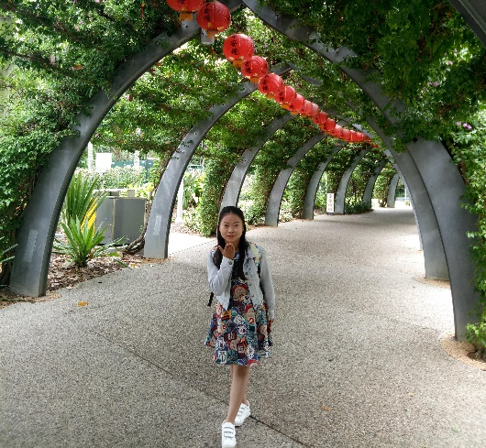
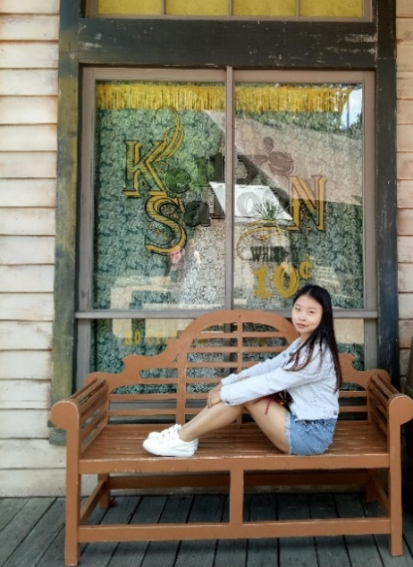
I love my major and I love teaching. I am delighted to be living in Australia and to experience teaching here. I am glad to be working with some friendly colleagues and happy to have classes with the students that are cute and occasionally naughty. I like the blue sky and white clouds here and like to meet students at school saying“Nǐhǎo” to me.
I wish to try my best to help the Chinese teachers, and to teach the students to learn to love Chinese language and Chinese culture.
我是郝俊霞，英文名字是Jasmine。我来自中国，我的家乡是河北邯郸，一个有着悠久历史文化的城市，许多中国典故和成语故事都来自我的家乡。我是首都师范大学的一名在读研究生，我的专业是汉语国际教育。现在，我在邦尼里格公立中学做汉语助教，到今年12月份结束。
我很喜欢我的专业，也很开心可以来到澳大利亚体验这里的教学和生活。很高兴有机会认识这里友好的同事，还可以和可爱又偶有调皮的学生一起上课。我喜欢这里的蓝天白云，喜欢课下见面时，学生用“你好”和我打招呼。
我希望能尽我所能辅助汉语老师进行教学，让学生真正地爱上汉语，感受中国文化。

