Dear Parents and Guardians

**SCHOOL UNIFORM FITTING FOR YEAR 7 2025**

Uniform fittings for Year 7 2025 are by APPOINTMENT ONLY and are compulsory for Year 7 students, so please **ensure that your child attends the fitting.**

Uniform fittings will be held in the school uniform shop (entrance via Elizabeth Drive) commencing Thursday 5 December 2024. We estimate fittings will take approximately 15 minutes per student.

The booking website will be available from 9.00am, 3 December 2024. If you have more than one child commencing Year 7, you will need to book separate fitting appointments for each child.

**To book your appointment follow the instructions below:**

1. Type <https://www.trybooking.com/CVCUH> into your web browser or use the QR Code below
2. Choose the date that best suits you
3. Choose the time that best suits you and press BOOK NOW
4. Select 1 Attendee by pressing the + and Click NEXT
5. Please enter the student’s first name, last name, and address
6. Please enter a parent or guardian’s phone number and email
7. Click PURCHASE (please note there is no cost involved to book your appointment

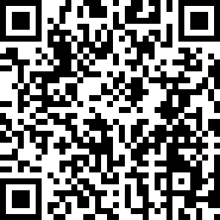

Your booking confirmation will be emailed to you automatically – check your junk mail folder if you do not receive your email immediately. To change your booking go to your confirmation email and select CANCEL TICKETS. If you wish to make a new booking, you will need to repeat the above booking process.

For parents and guardians that do not have access to the internet please contact Bonnyrigg High School on 9823 1184 and the office staff will assist you with the booking.

**Payment Methods:**

**Morning Session:** CASH, Cheque or EFTPOS – All Cash and Cheque payments are to be made at the school office after your child’s fitting.

**Afternoon Session:** EFTPOS ONLY

**PLEASE NOTE: THERE IS NO ONSITE PARKING AVAILABLE PRIOR TO 3:15PM**

انقر هنا للقراءة باللغة العربية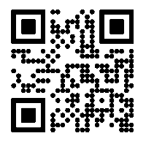

bấm vào đây để đọc bằng tiếng việt