New reads April 2015

Touch by Claire North  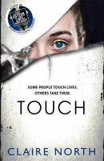 | He tried to take my life. Instead I took his. It was a long time ago. I remember it was dark, and I didn't see my killer until it was too late. As I died, my hand touched his. That's when the first switch took place. Suddenly, I was looking through the eyes of my killer, and I was watching myself die. Now switching is easy. I can jump from body to body, have any life, be anyone. Some people touch lives. Others take them. I do both.

Nona and Me by Clare Atkins | Rosie and Nona are sisters. Yapas. They are also best friends. It doesn't matter that Rosie is white and Nona is Aboriginal: their family connections tie them together for life. Born just five days apart in a remote corner of the Northern Territory, the girls are inseperable, until Nona moves away at the age of nine. By the time she returns, they're in Year 10 and things have changed. Rosie has lost interest in the community, preferring to hang out in the nearby mining town, where she goes to school with the glamorous Selena, and Selena's gorgeous older brother Nick. When a political announcement highlights divisions between the Aboriginal community and the mining town, Rosie is put in a difficult position: will she be forced to choose between her first love and her oldest friend?
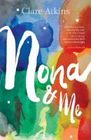
Two Wolves by Tristan Bancks  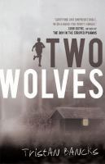 | One afternoon, police officers show up at Ben Silver's front door. Minutes after they leave, his parents arrive home. Ben and his little sister Olive are bundled into the car and told they're going on a holiday. But are they? It doesn't take long for Ben to realise that his parents are in trouble. Ben's always dreamt of becoming a detective - his dad even calls him 'Cop'. Now Ben gathers evidence and tries to uncover what his parents have done. The problem is, if he figures it out, what does he do? Tell someone? Or keep the secret and live life on the run?

Bleaker boy and Hunter stand out in the rain by Steve Herrick  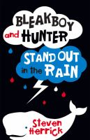 | Some things are too big for a boy to solve. Jesse is an eleven-year-old boy tackling many problems in life, especially fitting in to a new school. Luckily he meets Kate. She has curly black hair, braces and an infectious smile. She wants to 'Save the Whales' and needs Jesse's help. But they haven't counted on Hunter, the school bully, who appears to enjoy hurling insults at random. With Hunter's catchphrase 'Ha!' echoing through the school, something or someone has to give. But will it be Jesse? Kate? Or is there more to Hunter than everyone thinks?

The Minnow by Diana Sweemey | Tom survived a devastating flood that claimed the lives of her sister and parents. Now she lives with Bill in his old shed by the lake. But it's time to move out - Tom is pregnant with Bill's baby. Jonah lets her move in with him. Mrs Peck gives her the Fishmaster Super Series tackle box. Nana is full of gentle good advice and useful sayings. And in her longing for what is lost, Tom talks to fish: Oscar the carp in the pet shop, little Sarah catfish who might be her sister, an unhelpful turtle in a tank at the maternity ward. And the minnow.
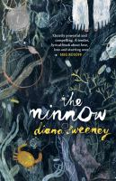
Second Life by SJ Watson  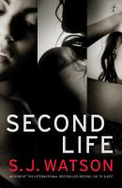 | She loves her husband. She's obsessed by a stranger. She's a devoted mother. She's prepared to lose everything. She knows what she's doing. She's out of control. She's innocent. She's guilty as sin. She's living two lives. She might lose both.

Shift by Hugh Howey  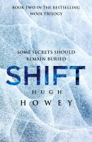 | In a future less than fifty years away, the world is still as we know it. Time continues to tick by. The truth is that it is ticking away. A powerful few know what lies ahead. They are preparing for it. They are trying to protect us. They are setting us on a path from which we can never return.

Dust by Hugh Howey  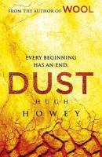 | In a time when secrets and lies were the foundations of life, someone has discovered the truth. And they are going to tell. Jules knows what her predecessors created. She knows they are the reason life has to be lived in this way. And she won't stand for it. But Jules no longer has supporters. And there is far more to fear than the toxic world beyond her walls. A poison is growing from within Silo 18. One that cannot be stopped. Unless Silo 1 step in.

The day no one was angry by Toon Tellegen and Marc Boutavant  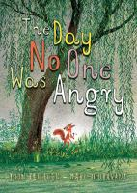 | 12 short chapters, we see different animals in various states of anger. Some try to understand their anger, some try to tame it, while others let their anger overwhelm them. These stories are funny and wry, but also offer a gently profound reflection of the nature of human emotions. Marc Boutavant's delicate, stunning full colour illustrations put the reader in the heart of the forest, surrounded by endearingly grumpy animals. This book is a beautifully produced hardback which would make the perfect gift for older children as well as adults.

The Protected by Claire Zorn  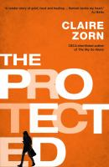 | Hannah's world has imploded, all thanks to her older sister Katie. Her mum is depressed, her dad's injured and she has to go to compulsory therapy sessions. Hannah should feel terrible but for the first time in ages, she feels a glimmer of hope and isn't afraid anymore. Is it because the elusive Josh is taking an interest in her? Or does it run deeper than that? In a family torn apart by guilt, one girl's struggle to come to terms with years of harassment shows how deep previous scars can run.

Birrung: the secret friend by Jackie French. [electronic resource] | The story of Boots, the ten-year-old orphaned son of a convict woman. Boots has survived Newgate and the voyage to Australia and his mother's death. Now Boots hides his younger sister Evie from the predominantly male colony, only venturing out to get the daily rations, and hiding among the colony of mud huts to try to get the food to his sister before it is stolen. An Aboriginal girl, Birrung, becomes Boots's friend and protector, introducing him to the Johnstones and their abundant vegetable garden. As the colony sinks into despair, terror and hunger, Birrung helps Boots and Evie survive, but she must remain his secret friend.

The war at the edge of the world by Ian Ross. [electronic resource]  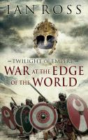 | The epic first instalment in a sequence of novels set at the end of the Roman Empire, during the reign of the Emperor Constantine. Centurion Aurelius Castus - once a soldier in the elite legions of the Danube - believes his glory days are over, as he finds himself in the cold, grey wastes of northern Britain, battling to protect an empire in decline. When the king of the Picts dies in mysterious circumstances, Castus is selected to guard the Roman envoy sent to negotiate with the barbarians beyond Hadrian's Wall. Here he will face the supreme challenge of command, in a mission riven with bloodshed and treachery, that tests his honour to the limit. As he struggles to avert disaster and keep his promise to a woman he has sworn to protect, Castus discovers that nothing about this doomed enterprise was ever what it seemed.

